**Welcome to my World**

**Code:  
login page:**

import '/flutter_flow/flutter_flow_theme.dart';

import '/flutter_flow/flutter_flow_util.dart';

import '/flutter_flow/flutter_flow_widgets.dart';

import 'package:flutter/material.dart';

import 'package:google_fonts/google_fonts.dart';

import 'package:provider/provider.dart';

import 'loginpage_model.dart';

export 'loginpage_model.dart';

class LoginpageWidget extends StatefulWidget {

const LoginpageWidget({super.key});

@override

State<LoginpageWidget> createState() => _LoginpageWidgetState();

}

class _LoginpageWidgetState extends State<LoginpageWidget> {

late LoginpageModel _model;

final scaffoldKey = GlobalKey<ScaffoldState>();

@override

void initState() {

super.initState();

_model = createModel(context, () => LoginpageModel());

_model.mailTextController ??= TextEditingController();

_model.mailFocusNode ??= FocusNode();

_model.passTextController ??= TextEditingController();

_model.passFocusNode ??= FocusNode();

_model.cpassTextController ??= TextEditingController();

_model.cpassFocusNode ??= FocusNode();

}

@override

void dispose() {

_model.dispose();

super.dispose();

}

@override

Widget build(BuildContext context) {

return GestureDetector(

onTap: () => _model.unfocusNode.canRequestFocus

? FocusScope.of(context).requestFocus(_model.unfocusNode)

: FocusScope.of(context).unfocus(),

child: Scaffold(

key: scaffoldKey,

backgroundColor: FlutterFlowTheme.of(context).primaryBackground,

appBar: AppBar(

backgroundColor: FlutterFlowTheme.of(context).primary,

automaticallyImplyLeading: false,

title: Align(

alignment: AlignmentDirectional(0, 0),

child: Text(

'Welcome to the My World',

style: FlutterFlowTheme.of(context).headlineMedium.override(

fontFamily: 'Outfit',

color: Colors.white,

fontSize: 22,

letterSpacing: 0,

),

),

),

actions: [],

centerTitle: false,

elevation: 2,

),

body: SafeArea(

top: true,

child: Column(

mainAxisSize: MainAxisSize.max,

children: [

Padding(

padding: EdgeInsetsDirectional.fromSTEB(8, 12, 8, 0),

child: TextFormField(

controller: _model.mailTextController,

focusNode: _model.mailFocusNode,

autofocus: true,

obscureText: false,

decoration: InputDecoration(

labelText: 'Email',

labelStyle:

FlutterFlowTheme.of(context).labelMedium.override(

fontFamily: 'Readex Pro',

letterSpacing: 0,

),

hintStyle:

FlutterFlowTheme.of(context).labelMedium.override(

fontFamily: 'Readex Pro',

letterSpacing: 0,

),

enabledBorder: UnderlineInputBorder(

borderSide: BorderSide(

color: FlutterFlowTheme.of(context).alternate,

width: 2,

),

borderRadius: BorderRadius.circular(8),

),

focusedBorder: UnderlineInputBorder(

borderSide: BorderSide(

color: FlutterFlowTheme.of(context).primary,

width: 2,

),

borderRadius: BorderRadius.circular(8),

),

errorBorder: UnderlineInputBorder(

borderSide: BorderSide(

color: FlutterFlowTheme.of(context).error,

width: 2,

),

borderRadius: BorderRadius.circular(8),

),

focusedErrorBorder: UnderlineInputBorder(

borderSide: BorderSide(

color: FlutterFlowTheme.of(context).error,

width: 2,

),

borderRadius: BorderRadius.circular(8),

),

),

style: FlutterFlowTheme.of(context).bodyMedium.override(

fontFamily: 'Readex Pro',

letterSpacing: 0,

),

validator:

_model.mailTextControllerValidator.asValidator(context),

),

),

Padding(

padding: EdgeInsetsDirectional.fromSTEB(8, 12, 8, 0),

child: TextFormField(

controller: _model.passTextController,

focusNode: _model.passFocusNode,

autofocus: true,

obscureText: !_model.passVisibility,

decoration: InputDecoration(

labelText: 'Password',

labelStyle:

FlutterFlowTheme.of(context).labelMedium.override(

fontFamily: 'Readex Pro',

letterSpacing: 0,

),

hintStyle:

FlutterFlowTheme.of(context).labelMedium.override(

fontFamily: 'Readex Pro',

letterSpacing: 0,

),

enabledBorder: UnderlineInputBorder(

borderSide: BorderSide(

color: FlutterFlowTheme.of(context).alternate,

width: 2,

),

borderRadius: BorderRadius.circular(8),

),

focusedBorder: UnderlineInputBorder(

borderSide: BorderSide(

color: FlutterFlowTheme.of(context).primary,

width: 2,

),

borderRadius: BorderRadius.circular(8),

),

errorBorder: UnderlineInputBorder(

borderSide: BorderSide(

color: FlutterFlowTheme.of(context).error,

width: 2,

),

borderRadius: BorderRadius.circular(8),

),

focusedErrorBorder: UnderlineInputBorder(

borderSide: BorderSide(

color: FlutterFlowTheme.of(context).error,

width: 2,

),

borderRadius: BorderRadius.circular(8),

),

suffixIcon: InkWell(

onTap: () => setState(

() => _model.passVisibility = !_model.passVisibility,

),

focusNode: FocusNode(skipTraversal: true),

child: Icon(

_model.passVisibility

? Icons.visibility_outlined

: Icons.visibility_off_outlined,

size: 25,

),

),

),

style: FlutterFlowTheme.of(context).bodyMedium.override(

fontFamily: 'Readex Pro',

letterSpacing: 0,

),

validator:

_model.passTextControllerValidator.asValidator(context),

),

),

Padding(

padding: EdgeInsetsDirectional.fromSTEB(8, 12, 8, 0),

child: TextFormField(

controller: _model.cpassTextController,

focusNode: _model.cpassFocusNode,

autofocus: true,

obscureText: !_model.cpassVisibility,

decoration: InputDecoration(

labelText: 'Confirm Password',

labelStyle:

FlutterFlowTheme.of(context).labelMedium.override(

fontFamily: 'Readex Pro',

letterSpacing: 0,

),

hintStyle:

FlutterFlowTheme.of(context).labelMedium.override(

fontFamily: 'Readex Pro',

letterSpacing: 0,

),

enabledBorder: UnderlineInputBorder(

borderSide: BorderSide(

color: FlutterFlowTheme.of(context).alternate,

width: 2,

),

borderRadius: BorderRadius.circular(8),

),

focusedBorder: UnderlineInputBorder(

borderSide: BorderSide(

color: FlutterFlowTheme.of(context).primary,

width: 2,

),

borderRadius: BorderRadius.circular(8),

),

errorBorder: UnderlineInputBorder(

borderSide: BorderSide(

color: FlutterFlowTheme.of(context).error,

width: 2,

),

borderRadius: BorderRadius.circular(8),

),

focusedErrorBorder: UnderlineInputBorder(

borderSide: BorderSide(

color: FlutterFlowTheme.of(context).error,

width: 2,

),

borderRadius: BorderRadius.circular(8),

),

suffixIcon: InkWell(

onTap: () => setState(

() => _model.cpassVisibility = !_model.cpassVisibility,

),

focusNode: FocusNode(skipTraversal: true),

child: Icon(

_model.cpassVisibility

? Icons.visibility_outlined

: Icons.visibility_off_outlined,

size: 25,

),

),

),

style: FlutterFlowTheme.of(context).bodyMedium.override(

fontFamily: 'Readex Pro',

letterSpacing: 0,

),

validator:

_model.cpassTextControllerValidator.asValidator(context),

),

),

Padding(

padding: EdgeInsetsDirectional.fromSTEB(0, 12, 0, 0),

child: FFButtonWidget(

onPressed: () async {

context.pushNamed('loggedinpage');

},

text: 'Login',

options: FFButtonOptions(

height: 40,

padding: EdgeInsetsDirectional.fromSTEB(24, 0, 24, 0),

iconPadding: EdgeInsetsDirectional.fromSTEB(0, 0, 0, 0),

color: FlutterFlowTheme.of(context).primary,

textStyle: FlutterFlowTheme.of(context).titleSmall.override(

fontFamily: 'Readex Pro',

color: Colors.white,

letterSpacing: 0,

),

elevation: 3,

borderSide: BorderSide(

color: Colors.transparent,

width: 1,

),

borderRadius: BorderRadius.circular(8),

),

),

),

],

),

),

),

);

}

}

**Loggedin page:**

import '/auth/firebase_auth/auth_util.dart';

import '/flutter_flow/flutter_flow_theme.dart';

import '/flutter_flow/flutter_flow_util.dart';

import '/flutter_flow/flutter_flow_widgets.dart';

import '/flutter_flow/flutter_flow_youtube_player.dart';

import 'package:flutter/material.dart';

import 'package:google_fonts/google_fonts.dart';

import 'package:provider/provider.dart';

import 'loggedinpage_model.dart';

export 'loggedinpage_model.dart';

class LoggedinpageWidget extends StatefulWidget {

const LoggedinpageWidget({super.key});

@override

State<LoggedinpageWidget> createState() => _LoggedinpageWidgetState();

}

class _LoggedinpageWidgetState extends State<LoggedinpageWidget> {

late LoggedinpageModel _model;

final scaffoldKey = GlobalKey<ScaffoldState>();

@override

void initState() {

super.initState();

_model = createModel(context, () => LoggedinpageModel());

}

@override

void dispose() {

_model.dispose();

super.dispose();

}

@override

Widget build(BuildContext context) {

return YoutubeFullScreenWrapper(

child: GestureDetector(

onTap: () => _model.unfocusNode.canRequestFocus

? FocusScope.of(context).requestFocus(_model.unfocusNode)

: FocusScope.of(context).unfocus(),

child: Scaffold(

key: scaffoldKey,

backgroundColor: FlutterFlowTheme.of(context).primaryBackground,

appBar: AppBar(

backgroundColor: FlutterFlowTheme.of(context).primary,

automaticallyImplyLeading: false,

title: Align(

alignment: AlignmentDirectional(0, -1),

child: Text(

'Welcome to the Movie World',

style: FlutterFlowTheme.of(context).headlineMedium.override(

fontFamily: 'Outfit',

color: Colors.white,

fontSize: 22,

letterSpacing: 0,

),

),

),

actions: [],

centerTitle: false,

elevation: 2,

),

body: SafeArea(

top: true,

child: Container(

width: double.infinity,

decoration: BoxDecoration(

color: FlutterFlowTheme.of(context).secondaryBackground,

),

child: Column(

mainAxisSize: MainAxisSize.max,

children: [

Align(

alignment: AlignmentDirectional(0, -1),

child: Padding(

padding: EdgeInsetsDirectional.fromSTEB(0, 12, 0, 0),

child: FFButtonWidget(

onPressed: () async {

GoRouter.of(context).prepareAuthEvent();

await authManager.signOut();

GoRouter.of(context).clearRedirectLocation();

context.goNamedAuth('loginpage', context.mounted);

},

text: 'LogOut',

options: FFButtonOptions(

height: 40,

padding: EdgeInsetsDirectional.fromSTEB(24, 0, 24, 0),

iconPadding:

EdgeInsetsDirectional.fromSTEB(0, 0, 0, 0),

color: Color(0xFF39EFB3),

textStyle:

FlutterFlowTheme.of(context).titleLarge.override(

fontFamily: 'Outfit',

color: Color(0xFFE71D3A),

letterSpacing: 0,

),

elevation: 3,

borderSide: BorderSide(

color: Colors.transparent,

width: 1,

),

borderRadius: BorderRadius.circular(8),

),

),

),

),

Padding(

padding: EdgeInsetsDirectional.fromSTEB(0, 12, 0, 0),

child: FlutterFlowYoutubePlayer(

url: 'https://www.youtube.com/watch?v=ePOglweqy7o',

autoPlay: false,

looping: true,

mute: false,

showControls: true,

showFullScreen: true,

strictRelatedVideos: false,

),

),

Align(

alignment: AlignmentDirectional(0, 1),

child: Padding(

padding: EdgeInsetsDirectional.fromSTEB(0, 15, 0, 0),

child: FFButtonWidget(

onPressed: () async {

context.pushNamed(

'less2',

extra: <String, dynamic>{

kTransitionInfoKey: TransitionInfo(

hasTransition: true,

transitionType: PageTransitionType.leftToRight,

),

},

);

},

text: 'Next',

options: FFButtonOptions(

height: 40,

padding: EdgeInsetsDirectional.fromSTEB(24, 0, 24, 0),

iconPadding:

EdgeInsetsDirectional.fromSTEB(0, 0, 0, 0),

color: FlutterFlowTheme.of(context).primary,

textStyle:

FlutterFlowTheme.of(context).titleSmall.override(

fontFamily: 'Readex Pro',

color: Colors.white,

letterSpacing: 0,

),

elevation: 3,

borderSide: BorderSide(

color: Colors.transparent,

width: 1,

),

borderRadius: BorderRadius.circular(8),

),

),

),

),

Padding(

padding: EdgeInsetsDirectional.fromSTEB(0, 12, 0, 0),

child: ClipRRect(

borderRadius: BorderRadius.circular(8),

child: Image.network(

'https://i.pinimg.com/564x/48/ef/5e/48ef5e641deadffae9e55d88e4296cdd.jpg',

width: 360,

height: 360,

fit: BoxFit.cover,

),

),

),

],

),

),

),

),

),

);

}

}

**Less2 page:**

import '/flutter_flow/flutter_flow_theme.dart';

import '/flutter_flow/flutter_flow_util.dart';

import '/flutter_flow/flutter_flow_widgets.dart';

import '/flutter_flow/flutter_flow_youtube_player.dart';

import 'package:flutter/material.dart';

import 'package:google_fonts/google_fonts.dart';

import 'package:provider/provider.dart';

import 'less2_model.dart';

export 'less2_model.dart';

class Less2Widget extends StatefulWidget {

const Less2Widget({super.key});

@override

State<Less2Widget> createState() => _Less2WidgetState();

}

class _Less2WidgetState extends State<Less2Widget> {

late Less2Model _model;

final scaffoldKey = GlobalKey<ScaffoldState>();

@override

void initState() {

super.initState();

_model = createModel(context, () => Less2Model());

}

@override

void dispose() {

_model.dispose();

super.dispose();

}

@override

Widget build(BuildContext context) {

return YoutubeFullScreenWrapper(

child: GestureDetector(

onTap: () => _model.unfocusNode.canRequestFocus

? FocusScope.of(context).requestFocus(_model.unfocusNode)

: FocusScope.of(context).unfocus(),

child: Scaffold(

key: scaffoldKey,

backgroundColor: FlutterFlowTheme.of(context).primaryBackground,

appBar: AppBar(

backgroundColor: FlutterFlowTheme.of(context).primary,

automaticallyImplyLeading: false,

title: Align(

alignment: AlignmentDirectional(0, -1),

child: Text(

'World Cup Winners 2024',

style: FlutterFlowTheme.of(context).headlineMedium.override(

fontFamily: 'Outfit',

color: Colors.white,

fontSize: 22,

letterSpacing: 0,

),

),

),

actions: [],

centerTitle: false,

elevation: 2,

),

body: SafeArea(

top: true,

child: Column(

mainAxisSize: MainAxisSize.max,

children: [

FlutterFlowYoutubePlayer(

url: 'https://www.youtube.com/watch?v=3yiWqnKl7lQ',

autoPlay: false,

looping: true,

mute: false,

showControls: true,

showFullScreen: true,

strictRelatedVideos: false,

),

Padding(

padding: EdgeInsetsDirectional.fromSTEB(0, 12, 0, 0),

child: FFButtonWidget(

onPressed: () async {

context.pushNamed(

'loggedinpage',

extra: <String, dynamic>{

kTransitionInfoKey: TransitionInfo(

hasTransition: true,

transitionType: PageTransitionType.rightToLeft,

),

},

);

},

text: 'Go Home',

options: FFButtonOptions(

height: 40,

padding: EdgeInsetsDirectional.fromSTEB(24, 0, 24, 0),

iconPadding: EdgeInsetsDirectional.fromSTEB(0, 0, 0, 0),

color: FlutterFlowTheme.of(context).primary,

textStyle:

FlutterFlowTheme.of(context).titleSmall.override(

fontFamily: 'Readex Pro',

color: Colors.white,

letterSpacing: 0,

),

elevation: 3,

borderSide: BorderSide(

color: Colors.transparent,

width: 1,

),

borderRadius: BorderRadius.circular(8),

),

),

),

Padding(

padding: EdgeInsetsDirectional.fromSTEB(0, 10, 0, 0),

child: ClipRRect(

borderRadius: BorderRadius.circular(8),

child: Image.network(

'https://www.aljazeera.com/wp-content/uploads/2024/06/AP24181688666233-1719696907.jpg?resize=770%2C513&quality=80',

fit: BoxFit.cover,

),

),

),

],

),

),

),

),

);

}

}

**Pubspec.yaml:**

name: hello

description: A new Flutter project.

environment:

sdk: ">=3.0.0 <4.0.0"

dependencies:

flutter:

sdk: flutter

auto_size_text: 3.0.0

cached_network_image: 3.3.1

cloud_firestore: 4.17.3

cloud_firestore_platform_interface: 6.2.3

cloud_firestore_web: 3.12.3

collection: 1.18.0

firebase_auth: 4.19.5

firebase_auth_platform_interface: 7.2.6

firebase_auth_web: 5.11.5

firebase_core: 2.31.0

firebase_core_platform_interface: 5.0.0

firebase_core_web: 2.17.0

firebase_performance: 0.9.4+5

firebase_performance_platform_interface: 0.1.4+33

firebase_performance_web: 0.1.6+5

flutter_animate: 4.5.0

flutter_cache_manager: 3.3.1

font_awesome_flutter: 10.6.0

from_css_color: 2.0.0

go_router: 12.1.3

google_fonts: 6.1.0

google_sign_in: 6.1.5

google_sign_in_android: 6.1.20

google_sign_in_ios: 5.6.4

google_sign_in_platform_interface: 2.4.2

google_sign_in_web: 0.12.1

intl: 0.19.0

json_path: 0.7.2

page_transition: 2.1.0

path_provider: 2.1.3

path_provider_android: 2.2.5

path_provider_foundation: 2.4.0

path_provider_platform_interface: 2.1.2

plugin_platform_interface: 2.1.8

provider: 6.1.2

rxdart: 0.27.7

shared_preferences: 2.2.2

shared_preferences_android: 2.2.1

shared_preferences_foundation: 2.3.4

shared_preferences_platform_interface: 2.3.1

shared_preferences_web: 2.2.1

sign_in_with_apple: 4.3.0

sign_in_with_apple_platform_interface: 1.0.0

sign_in_with_apple_web: 1.0.1

sqflite: 2.2.6

stream_transform: 2.1.0

timeago: 3.6.1

url_launcher: 6.2.5

url_launcher_android: 6.3.0

url_launcher_ios: 6.2.5

url_launcher_platform_interface: 2.3.2

webview_flutter: 4.7.0

webview_flutter_android: 3.15.0

webview_flutter_platform_interface: 2.10.0

webview_flutter_wkwebview: 3.12.0

youtube_player_iframe:

git:

url: https://github.com/FlutterFlow/youtube_player_flutter.git

path: packages/youtube_player_iframe

dev_dependencies:

flutter_lints: 4.0.0

lints: 4.0.0

flutter_test:

sdk: flutter

flutter:

uses-material-design: true

assets:

- assets/images/

- assets/videos/

- assets/audios/

- assets/lottie_animations/

- assets/rive_animations/

- assets/pdfs/

**Firestore.rules**

rules_version = '2';

service cloud.firestore {

match /databases/{database}/documents {

match /users/{document} {

allow create: if request.auth.uid == document;

allow read: if request.auth.uid == document;

allow write: if request.auth.uid == document;

allow delete: if request.auth.uid == document;

}

}

}

**Firestore.indexes.json:**

{

"indexes": []

}

**APP:**

**Login page:**

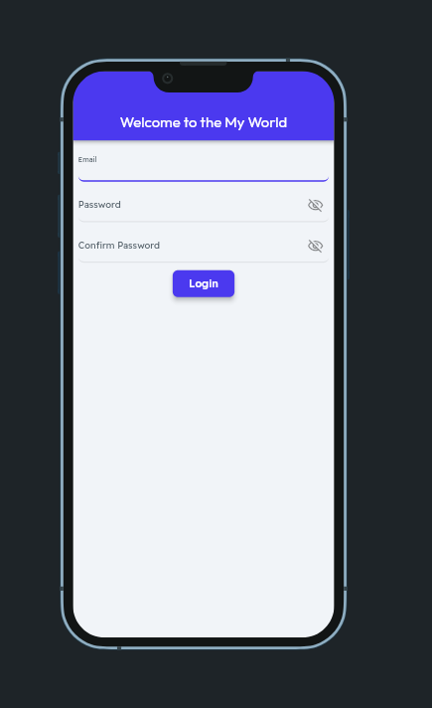

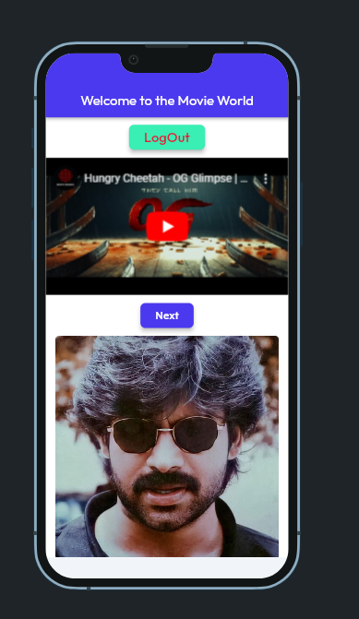

Click on NECT to go to the 3rd page

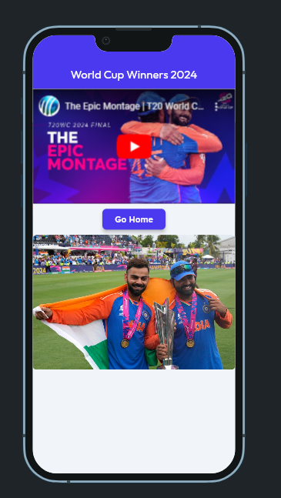

Click on home to go to the previous page